- Challenge Name and Category: 13 (Cryptography)
- Difficulty/Points: Easy.
- Description: Cryptography can be easy, do you know what ROT13 is? cvpbPGS{abg_gbb_onq_bs_n_ceboyrz}.
- Flag: picoCTF{not_too_bad_of_a_problem}
- Solution/Walkthrough: This cryptographic method was identified as Rot13. Any online tool that can decode Rot13 can be used here. Input “cvpbPGS{abg_gbb_onq_bs_n_ceboyrz}” and decipher.
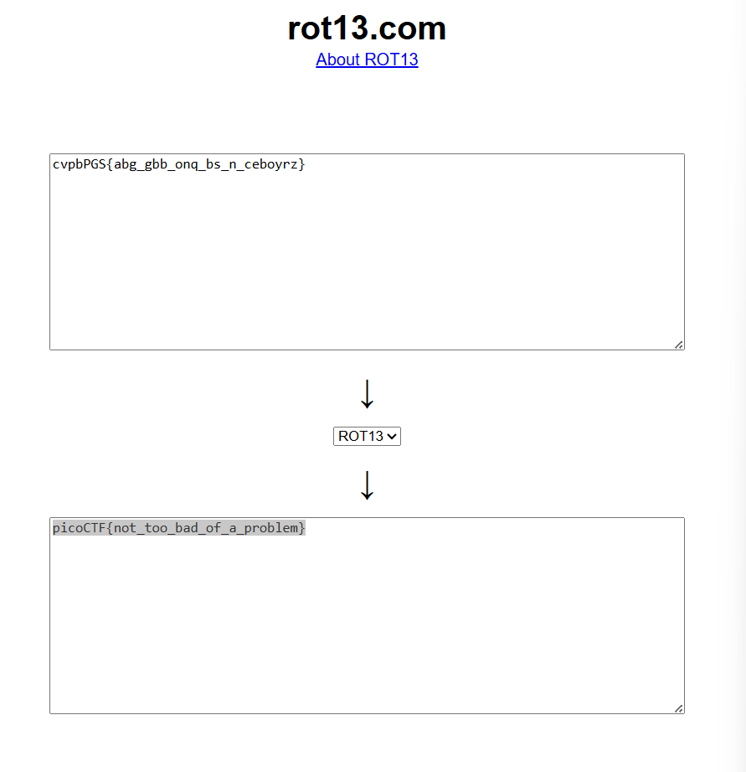
- Tools Used: https://rot13.com/
- Hypothesis Formulation: Decipher the flag from Rot13.
- What Worked vs. What Didn't: Deciphering the flag from Rot13 worked right away.

